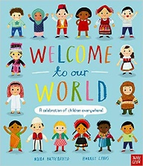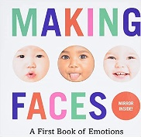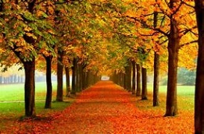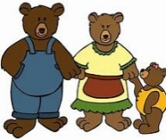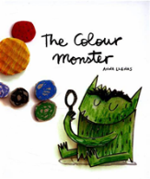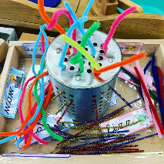

***Nursery Medium Term Plan***

***Autumn***

*The experiences outlined here will be included during Autumn Term but is not limited to these experiences. We will look forward to seeing where the children’s interests and needs take us during autumn.*

*Our Key texts are:*

*Our Non Fiction Texts are:*

**Specific Area: Literacy (L)**

Children will begin to identify and explore environmental sounds, instrumental sounds and body percussion.

We will:

* Go on listening walks
* Make music with our bodies
* Follow music sequences
* Make, listen and play music patterns using instruments and our bodies.

**Specific Area: Mathematics (M)**

* Geometry - Recognising, naming and matching colours.
* Sorting - By various attributes, Continuing AB patterns
* Measurement - Using the language of size
* Number & Place Value - Grasping the Counting Principles, Comparing amounts of objects

Through Goldilocks and the Three Bears we explore the meaning of size.

**Primer Area: Communication and Language (CL)**

We will take part in circle times to start to learn how to become confident talkers and listens to others.

We will start to listen and take parts in story times.

We will learn new nursery rhymes

We will sing new songs

We will begin to learn and use Makaton

We will watch how stories can be talked and acted out through ‘Helicopter Stories’

**Prime Area: Personal, Social and Emotional Development (PSED)**

Through our key text: The Colour Monster, we will learn:

* We all feel lots of feelings.
* There are labels for emotions.
* We can label some of our feelings.
* We are part of a caring, loving school and safe school.
* We can share our feeling with each other.

**Prime Area: Physical Development (PD)**

We are so lucky to take part in:

* Little movers (See description below)
* Yoga session (See description below)
* We have a funky finger table set up with different activities each week to promote fine motor skills.
* We take part in a PE lesson once a week – this term our focus is
* We have fabulous open ended outdoor resources chosen to challenge our fine and gross motor development.
* Hula Hoop day

**Specific Area: Understanding the World (UW)**

We will learn about and explore:

* Bonfire Night, Diwali, Harvest, Autumn, Christmas, Remembrance Sunday
* What it is like to live in Hexham and other Countries
* Autumn: Natural observation and experiences

Seasonal food, art.

**Specific Area: Expressive Arts and Design (EAD)**

Through our key text we will:

* Colour collage
* Paint with colours.
* Mix colours

We will have access to the:

* Work bench
* Small and large box modelling
* Play dough area

Our traditional Tales are: Goldilocks and the Three Bears and Little Red Riding Hood.

