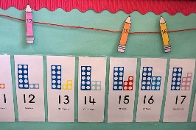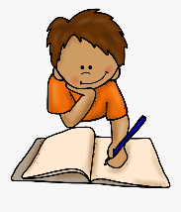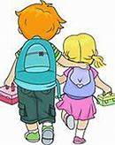

**Specific Area: Understanding the World (UW)**

We will learn about and explore:

Plants have roots, stems/stalks, leaves and flowers.

Baby animals are sometimes known by different names to the adult. Spiders have 8 legs. Insects have 6 legs.

We are all unique, I can recognise the uniqueness in others. Other people can have similarities to me. It is good to be different and we must always show kindness and respect towards everyone.

Humans can look after their bodies in many ways.

**Prime Area: Personal, Social and Emotional Development (PSED)**

Our end of year curriculum goal:

To become a ‘Kind and Confident’ cookie, who shows empathy to others, determination to complete a goal, resilience in the face of challenges, shows curiosity in the world around them and to identify what is unique about themselves and recognise uniqueness in others. Describes, understands and demonstrates healthy choices surrounding self-care.

We will use circle times, interactions, provision to support children achieve this.

**Specific Area: Literacy (L)**

Our end of year curriculum goal:

To become a ‘Sentence Superstar’ who can write sentences (with words containing single sounds and digraphs) and who can also independently write for a variety of purposes for someone else to read. E.g. Shopping list, story, model label, questions.

To become a ‘fabulous phonics extraordinaire’ who can read books containing words they can decode.

To become a ‘Sentence Superstar’ who can write sentences (with words containing single sounds and digraphs) and who can also independently write for a variety of purposes for someone else to read. E.g. Shopping list, story, model label, questions.

***Reception Medium Term Plan***

***Summer***

*The experiences outlined here will be included during Summer Term but is not limited to these experiences. We will look forward to seeing where the children’s interests and needs take us during autumn.*

*Our Key texts are:*

*Our Non-fiction Books are:*

**Specific Area: Mathematics (M)**

To 20 and beyond Building numbers beyond 10 Counting patterns beyond 10 Spatial reasoning (1) First, then, now Adding more Taking away Spatial reasoning (2)

Find my pattern Doubling Sharing and grouping Even and odd Spatial reasoning (3) On the move Deepening understanding Patterns and relationships Spatial reasoning (4)

**Primer Area: Communication and Language (CL)**

Our end of year curriculum goal:

To become a ‘Curious Chatterbox’ who can ask relevant questions and make comments, chat back and forth with friends and adults and express ideas and feeling with confidence, explaining their informed choices to others. To use learnt, meaningful vocabulary in a wide variety of contexts.

**Prime Area: Physical Development (PD)**

Our end of year curriculum goal:

To become a ‘confident adventurer’ who can use strength, balance and coordination to run, jump, hop, skip, climb, dance and cycle confidently and safely.

To become a ‘Funky Finger user’ who holds a pencil effectively and uses cutlery with confidence.

We will enjoy Little Movers sessions, sports day and our provision to support children achieve this.

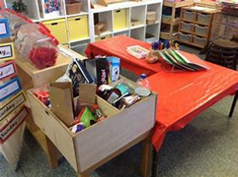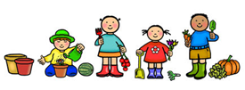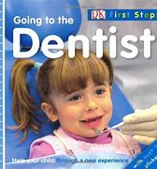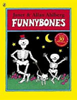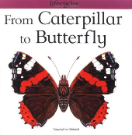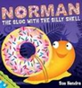

**Specific Area: Expressive Arts and Design (EAD)**

We will have access to the:

* Craft area
* Paint
* Playdough
* Small and large box modelling
* Collage
* Work bench

We will explore these areas through our own interests and invitation linked to the key texts.

Our traditional tale is Jack and the Beanstalk.