Year 4 Spring Term Topic Plan
Humanities |  |  | Science
Anglo Saxons | Go with the Flow  The River Tyne – Bridges  The water cycle |  | States of Matter – Solids, liquids  and gases  All Living Things
Enrichment | Invasion! | English (including books) |  | Mathematics
TRIP to the river to link with Go with the Flow  River Tyne Project – Water cycle  Chinese New Year – Art |  | Firework Maker’s Daughter  Diary  Letters  Recounts  Quest story writing – Talk for writing |  | Number: Multiplication and division  Measurement: Area  Number: Fractions  Number: Decimals
The Creative Arts |  | The Performing Arts |  | Physical Education
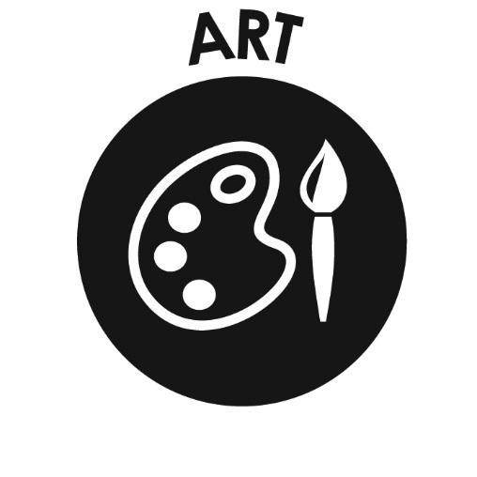  D.T. - Anglo Saxon Broaches with clay  Art – Monet water lilies with water colours |  | Charanga music |  | Gymnastics with  Mr Brown  Swimming
Computing | Languages | Religious Education |  | PSHE
Programming - repetition in games | 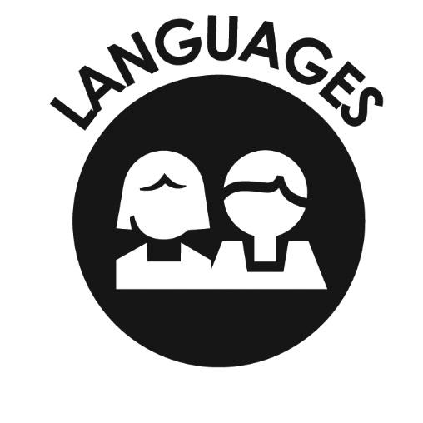  Language angels  French - Fruit | Buddhism:  Stories |  | 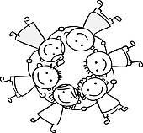  Growth mindset  Physical Health and wellbeing  Keeping safe and managing risk  Kapow

