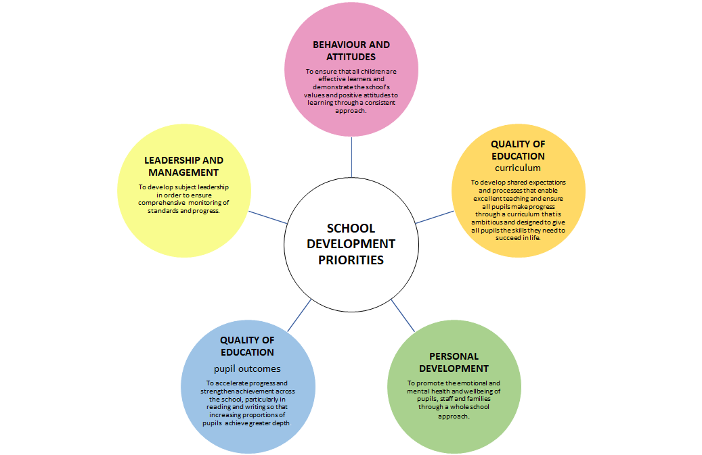

School Priority 1  LEADERSHIP AND MANAGEMENT | To develop the role of subject leaders in order to ensure comprehensive monitoring of standards and progress.

Focus  (specific targets) | Benchmark:  (existing position) | Shared Criteria:  (How do we get there? Strategies) | Person responsible  timescale | Success Criteria:  (What will the impact be? How will we know?) | Impact statement  (evidence?)
Subject leaders to have a clear understanding of their subject curriculum intent, and it’s implementation in school  . | Some subjects have action plans  Some focussed CPD opportunities provided for staff - Mastery maths, RWI, Pie Corbett, Mantle of the Expert | - Staff produce subject action plans with specific manageable actions that include monitoring of knowledge and skills through termly book scrutiny and learning walks  - Staff support colleagues with medium term plans, CPD and learning opportunities  - Staff take proactive ownership of their areas to ensure consistency of policies and standards | Subject Leaders  Oct 2018  Subject Leaders / HT  Half termly | - Action plans are focussed with specific actions and timescale.  - Opportunities for CPD are evident with time given in staff meetings to feedback  - Teachers are confident in the teaching of all curriculum subjects  - Subject leaders confidently talk about curriculum coverage and progression within their subject so that teachers build on prior knowledge if a topic is repeated.  - Subject leaders know what schemes of work are used in their subject.  - Staff feel supported and their subject knowledge is secure. | Action plans produced and shared with HT and governors  Support provided with medium term planning  Monitoring of standards in Geography, English, reading
Subject leaders to have a clear understanding of standards within their subjects | Subject leaders have used ‘Weaving Knowledge’ to look at progression in the foundation subjects | - Subject leaders have a detailed understanding of how well pupils are doing and what next steps cohorts should take  - All subject leaders can evidence a range of monitoring that has enabled them to have a good overview of their subject  - Subject data has been analysed by subject leaders | Subject leaders  Termly | - Subject leaders can talk confidently about standards within their subject.  - Subject data analysis is fed into action plans  - Subject priorities link with school development plan | Monitoring timetable  Partnership moderation  Focus of Gov visits  Focus of SIP visit
EYFS leader to have a clear and ambitious vision for providing inclusive care and education to all. This is realised through strong shared values, policies and practise. | Clear vision for EYFS shared by leader and staff.  EYFS policy in place.  Some staff CPD taking place - LA network meetings, SALT training, Lego therapy. Cascading of training received as part of EY Maths TRG | 1. EY leader to create action plan with focus on improving practitioners’ knowledge of the areas of learning and understanding of how children learn to enhance the teaching of the curriculum and appropriate use of assessment.  2.EY leader develops effective systems for supervision and support of staff | EY leader  Dec 2019 | - Action plan is focussed with specific actions and timescales  - Opportunities for CPD are evident.  - Practice and subject knowledge of EY practitioners builds and improves over time.

School Priority 2  QUALITY OF EDUCATION - CURRICULUM | To develop shared expectations and processes that enable excellent teaching and ensure all pupils make progress through a curriculum that is ambitious and designed to give all pupils the knowledge and skills they need to succeed in life.

Focus  (specific targets) | Benchmark:  (existing position) | Shared Criteria:  (How do we get there? Strategies) | Person responsible timescale | Success Criteria:  (What will the impact be? How will we know?) | Impact statement  (evidence?)
A clear understanding by all staff of the curriculum (including EYFS ) intent | Some staff have received CPD on Curriculum Intent (maths) | Develop a whole school foundation subject coverage map (intent) to identify knowledge and skills that pupils need, based on prior teaching | HT / subject leaders  December | Subject leaders can talk confidently about the curriculum intent and implementation | Progression in Geography mapped out  Changes to geography curriculum linked with school context
Progression of knowledge and skills is understood by all teaching staff | Weaving Skills document has been used in past 2 years by teachers.  EYFS implemented | Divide phase related curriculum objectives into specific year groups to aid the fluid progression of skills, ensuring an overlap of the core skills that span the phase. | subject leaders  December | Teachers have a clear understanding of the progression of knowledge and skills for their class and the knowledge and skills previously acquired  EYFS practitioners ensure that content, sequencing and progression in areas of learning are secured.
Staff are knowledgeable about the importance of long term memory learning | Staff have not had specific CPD on importance of long term memory learning | Identify key concepts to be embedded in pupils’ long term memory and used fluently without memorising disconnected facts (implementation) | subject leaders  Spring Term | Teachers have a good knowledge of how making connections and long term memory can have an impact on progress and attainment.
Assessment systems reflect the subject end points | End of Block Assessments used in Maths and half termly in English;  Bug Club reading comprehension assessment and writing assessments done half termly from years 1 -4 | Develop clear end points that the curriculum is building towards and systems for leaders to monitor pupils’ progress towards meeting these (impact) | HT/ subject leaders  Ongoing | Teachers have a clear understanding of the knowledge and skills the pupils need to meet the expected standard in each subject
Staff use the whole school environment to enhance teaching and learning. | Nurture group gave all children a chance to experience learning outside of the classroom  Large scale changes made to EY outside area to increase opportunities for child initiated learning/ open ended learning in natural environment. | Outdoor Learning is included and timetables and used to enhance planning across the curriculum. | All Staff  Summer Term | Children have regular opportunities to use the whole school environment
Children are provided with a wide range of learning experiences that are ambitious, memorable and exciting | Staff collated enrichment opportunities list for each child’s time at Hexham First- includes- live theatre, cinema, art gallery, library, churches, seaside, castle, woods. | Subject leaders and HT plan a systematic programme of experiences that enhance the curriculum. | All staff  Ongoing | Enrichment opportunities continue to be a strength of the school with further opportunities explored.

School Priority 3  QUALITY OF EDUCATION - pupil outcomes | To accelerate progress and strengthen achievement across the school, so that increasing proportions of pupils achieve greater depth (Exceeding in EYFS??)

Focus  (specific targets) | Benchmark:  (existing position) | Shared Criteria:  (How do we get there? Strategies) | Person responsible/timescale | Success Criteria:  (What will the impact be? How will we know?) | Impact statement  (evidence?)
Increase proportions of pupils achieving greater depth in reading, writing and maths | R W M  GDS % GDS % GDS %  Year 1 4 % 4 % 0  Year 2 33 % 17 % 17 %  Year 3 28 % 17 % 17 %  Year 4 0 5 % 0  total 14 % 10 % 7 %  Quality First teaching  Interventions |  | Teachers  LSA’s | A higher percentage of children will achieve greater depth in reading, writing and maths throughout the school.
Early identification of children who could make better than expected progress | This has not been a focus previously.  *Has been addressed in year 2 in the past. | KS2 learning support assistant timetabled to work with identified children during afternoon sessions to help accelerate progress | J.O  All Teachers | A higher percentage of children will achieve greater depth in reading, writing and maths throughout the school.
Staff CPD to explicitly teach the journey from reading into writing. | Spring term - Trawl project (Teaching Reading and writing Links)  Some staff have had Pie Corbett training | High quality texts are used to teach the journey from reading into writing | C.C.  All Teachers | Monitoring - evidence in books and pupil voice show the journey from reading into writing | Reciprocal reading strategies being trialled in Yr 4 with CPD for YR teacher planned in Spring 2
To link long term English plans with high quality texts and class topics showing clear progression in all genres from Early Years to Year 4 | Each class has a range of books from Pie Corbett reading spine - they are used in planning to ensure the use of high quality texts. | English lead to produce an overview of genres taught in each year group and review of texts | H.B  November | Progression is evident in books and lesson observations and pupil voice | Overview of genres produced by English lead
To investigate ways to inspire boys to write. | TRAWL questionnaires show that TRAWL has had some impact with this. | English Lead and teachers to review research into the impact of activities to inspire boys to write | Spring Term | Progression is evident in books and lesson observations and pupil voice
Continue to promote a vibrant reading culture and a love of reading across school. | Each class visits local book shops yearly and the library termly. There is an annual ‘storytelling’ evening.  Reading volunteer in school on a weekly basis. | Teachers as role models, planned time in class for reading - independently, guided, whole class and being read to by an adult. | All staff  Autumn  Spring  Summer | Increased number of children reading for pleasure  Profile of reading raised  Information about the impact of reading shared with parents.  PTA raising funds for new reading books
Plan activities and events to foster a love of reading (reading week, reading breakfast, book fairs, extreme reading, competitions, secret readers). | Annual storytelling evening  Story focused ‘World Book’ day activities.  English lead produced a yearly plan outlining reading events. | Planned reading events on google school calendar.  Introduction of World Nursery Rhyme Week into EY & Y1 - involve parents & element of performance/recall poetry from memory. | HB  ½ termly  ZJ,FW,EB | Increased number of children reading for pleasure  Profile of reading raised  Information about the impact of reading shared with parents
Increase proportion of children  achieving Exceeding in EYFS Profile | See 2019 EYFS Profile  EY leader attended Maths Hub training 2018/19 - target to develop strategies to identify and support children working at Exceeding level in Number and SSM. | Implementation of Planning in the Moment to ensure that children are deeply engaged in their work and play, sustaining high levels of concentration and being provided with high (and appropriate) levels of challenge. | Teachers  LSAs | Higher proportion of children will achieve Exceeding in EYFS Profile

School Priority 4  BEHAVIOUR AND ATTITUDES | To ensure that all children are effective learners and demonstrate the school’s values and positive attitudes to learning through a consistent approach.

Focus  (specific targets) | Benchmark:  (existing position) | Shared Criteria:  (How do we get there? Strategies) | Person responsible/timescale | Success Criteria:  (What will the impact be? How will we know?) | Impact statement  (evidence?)
All staff have a shared understanding of behaviour expectations | While behaviour in the school is usually good, behaviour could be improved by staff, pupils and parents being clear about expectations of behaviour | - Introduce positive values based behaviour system that is consistent with school values - the Hexham Way.  - Learning attitudes rewarded through Class Dojo  - Routinely advertising behaviour that is acceptable and not behaviour that isn’t  - Ensure consistent use of traffic light system – no disproportionate sanctions  - Children taught and retaught expected behaviours  - Ensure that all stakeholders understand the behaviour system | Autumn  Spring  Summer | The incidents of unacceptable behaviour have reduced
To ensure our playtime spaces and activities are providing structure and engagement in healthy play | Some organised activities - skipping | - Older pupils to be trained in delivering activities for younger pupils  - All adults on duty to have a consistent approach to structuring playtimes | Autumn Term  Spring Term | Playground buddies leading by example  Sports leaders organising games  All staff support healthy play
To use CPOMS to effectively monitor incidents of bullying, racism, homophobic language | Paper based system  Errors in filing  Gaps in recording  Actions not recorded  Triangulation and monitoring not effective | - J.O to train staff on use of CPOMS  - Vigilance and consistency with regards to recording information  - Clear actions recorded after incidents | J.O  All teaching staff  Autumn Term | All incidents of bullying, racism and use of homophobic language are recorded with appropriate actions taken
To ensure that the new PSHE curriculum is embedded | Existing PSHE curriculum in place | School to adopt the new PSHE curriculum and ensure curriculum takes into account the statutory guidance for Relationships, RSE and Health education published in June 2019 | Autumn Term  J.M  J.O | New PSHE curriculum in place with monitoring | J.M attended full day training and scheme decided on.
All staff lead on the consistency around basic standards: positive behaviour, attitude, uniform, attendance and punctuality – ‘the little things matter’. - | Inconsistency with school policy and what is the reality | - Increase staff knowledge and understanding of why children misbehave and how best to combat or prevent poor behaviour and manage classrooms through staff training opportunities  - Consistent whole school behaviour system ( Class Dojo )used to reward children for expected behaviour and learning attitude - all staff, no separate systems  - To ensure that all school policies with regard to uniform and behaviour are followed consistently and all staff challenge | J.O  All staff  Autumn term | The incidents of unacceptable behaviour have reduced  Poverty Proofing is considered when implementing school policies  Children are wearing the correct uniform for school
To encourage pupils to look after the school environment by getting pupils to express their ideas about how they can best look after; take a pride in their school and action their thoughts and ideas. | School Council have discussed this. | - Eco Team support L.B in carrying out an environmental audit  - Staff member to be responsible for school participation in Eco school Programme – theme on litter and waste | L.B  J.O  Autumn | - Less Litter around school  - Recycling schemes commence  - Less plastic being used in school  - Children take more pride in school environment
To ensure that attendance is high and punctual | School has good relationship with EWO, low attendance is identified, letters sent out and parents/carers invited into school. Attendance also commented on in reports. | - Set up systems to monitor attendance on a weekly basis  - Early identification of low attendance  - Seek support from EWO  - Unauthorised absences discussed with governing body | Autumn Term  Spring Term  Summer Term | Attendance remains above 96 %  Incidents of poor attendance decrease

School Priority 5  PERSONAL DEVELOPMENT | To promote the emotional and mental health and well being of pupils, staff and families through a whole school approach

Focus  (specific targets) | Benchmark:  (existing position) | Shared Criteria:  (How do we get there? Strategies) | Person responsible/timescale | Success Criteria:  (What will the impact be? How will we know?) | Impact statement  (evidence?)
To support and develop the mental health and wellbeing of pupils, staff and families | Staff are very supportive of each other and generally feel able to discuss concerns with colleagues.  Staff have good relationships with parents and parents often informally share problems with staff.  EHAs used for some families.  PSHE curriculum has had a growth mindset focus over 1 term for several years.  KS1 children have half a term of yoga.  Year 2 have weekly massage. | - Values of resilience, being unique and growth mind-set explored in assemblies and class.  - To use pupil questionnaire and pupil voice to ascertain a baseline for current levels of pupil understanding of MH and WB. Information to be used to prioritise areas for curriculum planning and development.  To provide information to parents regarding the MHWB agenda, where they can seek support, guidance and advice if they have concerns about  their children  - To develop MHWB section on new school website to include advice and guidance for families –signposting to support both in school and externally  - To develop and embed ‘Growth Mindset’ approaches to enable pupils to become resilient and confident learners: | All staff | - Children to understand their emotions and feelings better  - Children feel comfortable sharing any concerns or worries  - Children develop socially to form and maintain relationships  - promote self-esteem and ensure children know that they count  - Children to be confident and ‘dare to be different’ - unique  - Children are persistent even when faced with challenges  - Children to develop emotional resilience and to manage setbacks  - Children to develop a ‘Growth Mindset’
To make sure that MHWB is explicitly taught | Growth Mindset is included in the PSHE planning. | To review current planning for PSHE in line with MHWB agenda – to incorporate explicit teaching of MHWB into the curriculum for PSHE. | All staff | - Pupil voice  - Staff voice  - Monitoring
To provide regular opportunities for  pupils to learn self-help strategies to  reduce anxiety, aggression and improve  well-being for example breathing  exercises, relaxation, yoga. | KS1 children have half a term of yoga.  Year 2 have weekly massage. | - Introduce sensory circuits for vulnerable children  - Seek external support were possible  - CPD for staff  - Work with Trailblazers MEntal HEalth team | All staff | Children are supported and anxiety and aggression reduced

