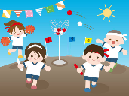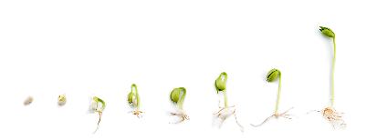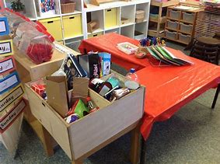

**Prime Area: Physical Development (PD)**

Our end of year curriculum goal:

To become an **‘Amazing Athlete**’  and develop body strength when climbing up, across and down various equipment, negotiating and rolling down the hill. Using bikes and scooters to whizz around and construct masterpieces on a large scale.  
To become a **‘Talented Tool User and Marvellous Mark Maker’’** regularly visiting the ‘funky finger’ table and other equipment that builds up hand and whole-body strength through adventurous play, to be able to enjoy mark making and confidently demonstrate a proficient grip.

We will enjoy Little Movers sessions, sports day and our provision to support children achieve this.

**Specific Area: Understanding the World (UW)**

We will learn about and explore:

* Plants, flowers and seeds
* Plants grow from seeds and bulbs. Plants need light, warmth, water and food to grow.
* Animals – caterpillars and butterflies
* Baby animals sometimes look similar or different to an adult.
* Looking after animals and understanding their habitats.
* Planting and caring for plants
* I am unique, I can recognise special things about myself.
* There are healthy choices for our bodies

**Specific Area: Expressive Arts and Design (EAD)**

We will have access to the:

* Craft area
* Paint
* Playdough
* Small and large box modelling
* Collage
* Work bench

We will explore these areas through our own interests and invitation linked to the key texts.

**Specific Area: Mathematics (M)**

Shape & Space - Shape

Measurement - Ordering the events of our day

Length and Height

Weight

Capacity

Shape & Space - Positional Language

***Nursery Medium Term Plan***

***Summer***

*The experiences outlined here will be included during Summer Term but is not limited to these experiences. We will look forward to seeing where the children’s interests and needs take us during Summer.*

*Our Key texts are:*

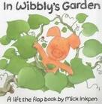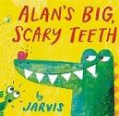

*Our Non Fiction Texts are:*

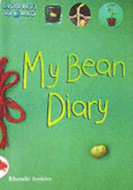 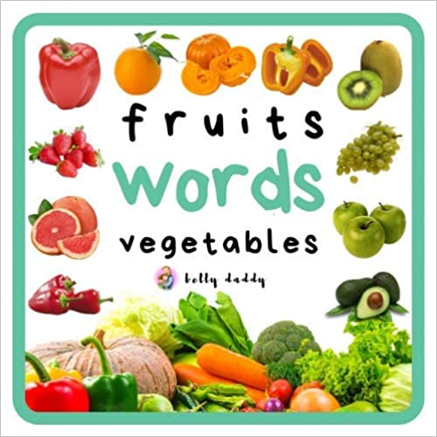

**Specific Area: Literacy (L)**

Children build on identifying and exploring environmental sounds, instrumental sounds and body percussion.

* We will continue to explore rhythm and rhyme activities.
* Children begin to copy exaggerated sounds such as ssssss and suggest words when given an initial sound. Children to begin to use alliteration and voice sounds. Oral blending and segmenting.

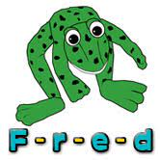

**Primer Area: Communication and Language (CL)**

Our end of year curriculum goal:

To become a **‘Confident Communicator’** in every day play and focussed sessions, showing the ability to follow instructions, concentrate, think through and extend ideas with real and imaginary thoughts with others. To use learnt, meaningful vocabulary in a wide variety of contexts.

We will use circle times, interactions, provisions to support children to achieve this.

**Prime Area: Personal, Social and Emotional Development (PSED)**

Our end of year curriculum goal:

To become an **‘Independent Individual and a Fantastic Friend**’ in Hexham First School, who happily greets and interacts with others, sharing thoughts and resources patiently, valuing self and others and willing to persist and not be daunted by challenge. Develop an awareness of what makes them unique and label some of their emotions.

We will use circle times, interactions, provision to support children achieve this.

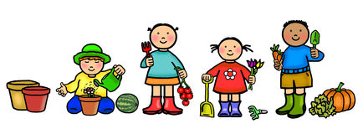Our Traditional Tales are Jack and the Beanstalk.