English  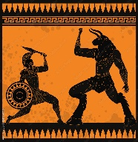  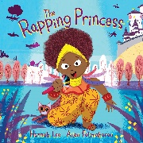  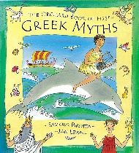  In English we will use a Talk4Writing approach and read lots of Greek myth stories in order to guide us into writing our own Greek myth. We will also take part in poetry performance, creating our own raps inspired by the book ‘The Rapping Princess’. We will then delve into the world of language play, looking at poems such as Spike Milligan’s ‘Ning Nang Nong’ and Lewis Carroll’s ‘The Jabberwocky’, using these poems to create our own versions. Our non-fiction unit will focus on non-chronological reports.  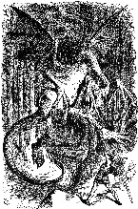  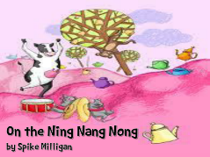 | Maths  In Maths we follow the White Rose scheme, and continue to use practical resources such as Base Ten in addition to using column methods to calculate addition and subtraction within 3-digit numbers. We will be adding and subtracting single digit and tens to and from 3-digit numbers using ‘exchange.’ We will practise our 2x,5x, 10 x tables and will begin to learn our 3x,4x and 8x tables. We will also look at measurement.  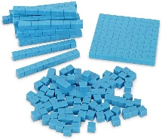  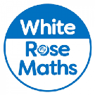 | Science  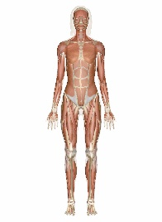  In our Science this term we will start with the topic ‘Food and our Bodies’, in which we will learn about nutrition, the skeleton and the muscular system.  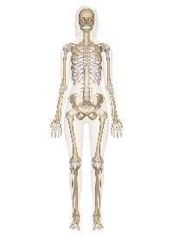  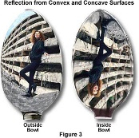  We will then move on to our ‘Light and shadows’ topic, through which we will learn about different light sources. We will investigate different mirrors and shadows.
P.E & French  In P.E we will take part in multi skills sessions led by Mr Brown. We will take part in a weekly Dance session.  This Photo by Unknown Author is licensed under CC BY-NC  In French we use the Language Angels programme. Through lots of verbal practice, we will learn some animal names and some fruits. | Enrichment  World Book Day  Kielder Observatory visit  Designing futuristic Hexham High Street  Celebrating Chinese New year with mask making  Books we will read together  VIPERS guided reading sessions:  Stig of the Dump  The Sheep Pig  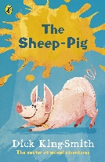  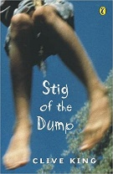  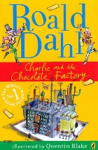  Charlie and the Chocolate Factory | Computing & Design Technology  In Computing, we will be learning about Desktop Publishing and creating some of our own media.  We will then learn about Branching Databases: using questions that have either a ‘yes’ or ‘no’ answer both physically to create branching databases and using J2Data, a branching databases computer tool  In Design and Technology, we will be designing and making healthy drinks and comparing them with commercially sold drinks.
Creative Arts  In Music we will be following the Charanga scheme and learning about pulse and learning to sing ‘3 Little Birds’ by Bob Marley.  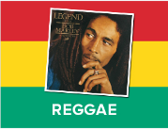  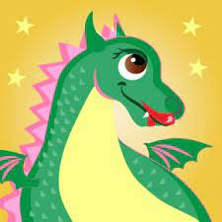  We will then learn to sing ‘The Dragon Song’ and begin to play glockenspiels. | Topic  In History we will be learning a lot about Ancient Greece, what time period this ancient civilisation covered, the geography of the land, the impact of their religion, warfare and famous influential people from that time.  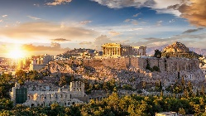  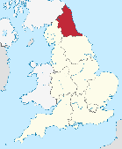  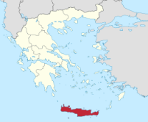  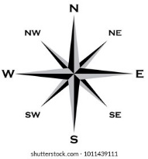  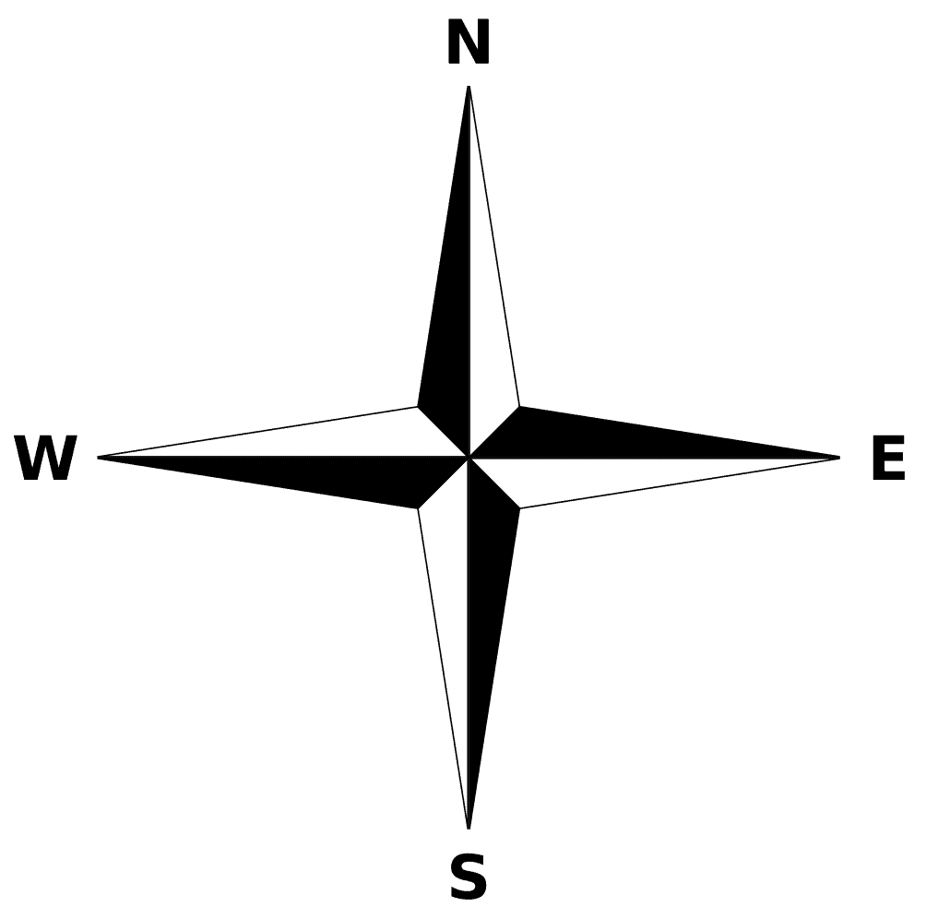  In Geography we will learn the difference between 4-point- and 8-point compasses. We will be looking at two regions within Europe; The North East of England and Crete, in Greece. We will be comparing 2 locations within each region. | RE & PSHE  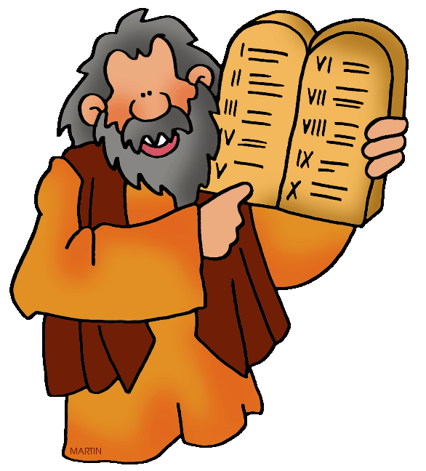  In RE we will be learning how there are rules in school and rules within different religions. We will learn about the Ten Commandments.  In PSHE we are following the Kapow scheme, and will be learning about Families and Relationships, followed by Health and Wellbeing.

