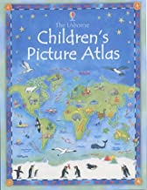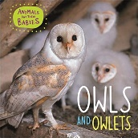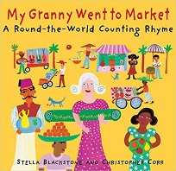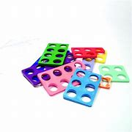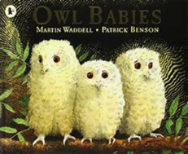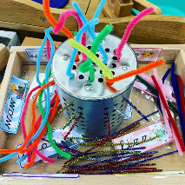

***Reception Medium Term Plan***

***Autumn***

*The experiences outlined here will be included during Autumn Term but is not limited to these experiences. We will look forward to seeing where the children’s interests and needs take us during autumn.*

*Our Key texts are:*

*Our Non-fiction Books are:*

**Specific Area: Literacy (L)**

Following the phonics scheme Read, Write, Inc. Children in Reception will:

Read single-letter Set 1 sounds and read all Set 1 sounds; blend sounds into words orally

We will:

* Retell a story
* Map stories and rhymes
* Understand that stories have a beginning, middle and end.
* Alter parts of stories and rhymes

**Specific Area: Mathematics (M)**

Getting Just like me: Match and sort Making comparisons (Compare

amounts Compare size, mass and capacity) Exploring Pattern (Make simple patterns) It’s me 1, 2, 3! Representing 1, 2, 3 Comparing 1, 2, 3 Composition of 1, 2, 3 Geometry and spatial thinking (Circles and triangles Spatial awareness) Light and dark Numbers to 5 (Four and Five One more and one less. Geometry and spatial thinking (Shapes with 4 sides) Measurement – Time (Night and day)

**Primer Area: Communication and Language (CL)**

We will take part in circle times listening appropriately and asking relevant questions

We will start to listen and take parts in story times.

We will learn new nursery rhymes

We will sing new songs

We will begin to learn and use Makaton

We will create and act out our stories in ‘Helicopter Stories’ sessions

**Prime Area: Personal, Social and Emotional Development (PSED)**

Through our key text: Owl babies, we will learn:

* Families come in all shapes and sizes.
* We can identify when we might feel worried and know what to do to help ourselves.
* We can understand when others might feel worried and offer help to them.

**Prime Area: Physical Development (PD)**

We are so lucky to take part in:

* Little movers (See description below)
* Yoga session (See description below)
* We have a funky finger table set up with different activities each week to promote fine motor skills.
* We take part in two PE lesson once a week – this term our focus is
* We have fabulous open ended outdoor resources chosen to challenge our fine and gross motor development.
* Hula Hoop day

Our traditional tales are Little Red Riding Hood and Goldilocks and the Three Bears.

**Specific Area: Understanding the World (UW)**

We will learn about and explore:

* Bonfire Night, Diwali, Harvest, Autumn, Christmas, Remembrance Sunday
* We live in Hexham, we can talk about some human and physical features of Hexham.
* We can see journeys on maps. We can make maps. We can talk about familiar and unfamiliar things we notice from different countries.
* Autumn: Natural observation and experiences

Seasonal food, art.

**Specific Area: Expressive Arts and Design (EAD)**

Through our key text we will:

* Make nests
* Explore owl art possibilities

We will have access to the:

* Craft area
* Paint
* Playdough
* Small and large box modelling
* Collage
* Key text exploration
* Work bench

