Hexham First School - Long term Plan 2025 - 26
Early years
 | Autumn 1  Transition  Starting school/new beginnings Rules and routines All about me, families, homes Feelings and emotions  Seasons - Autumn |  | Autumn 2  Journeys  Here or There?  Celebrations, parties  Bonfire Night, Remembrance Day  Harvest, Diwali,  Advent, Christmas  Seasons – Autumn |  | Spring 1  Here or There?  Comparing places  Polar regions and the desert  Recycling, looking after the world  Seasons - Winter |  | Spring 2  Then and Now  Seasons - Spring |  | Summer 1  Growth and animals  Growing and changing  Plants and flowers  Animals and minibeasts  Life cycles  Seasons – Summer |  |  | Summer 2  Unique Us  Human body, senses  Keeping fit and healthy  Seasons - Summer
Key Text | Cycle 1  Owl Babies  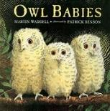  Non fiction Owls life cycle  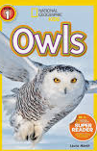 | Cycle 2  My Friend Harry - Kim Lewis- local author 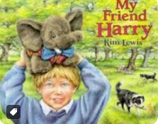  No fiction You choose toy/ teddy from home talk and describe why it is special etc. Photo with special thing and write. | Cycle 1  My Granny went to Market  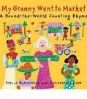  Going on a bear hunt  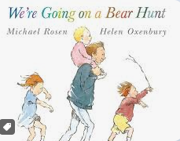 | Cycle 2  Handa’s Surprise  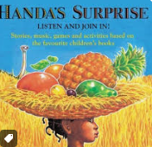  Shark in The Park  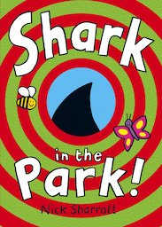 | Cycle 1  Polar bears No-fiction writing  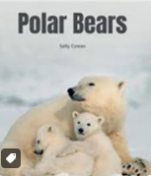  We’re the Ugly Five  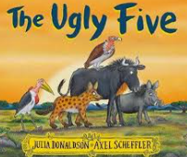 | Cycle 2  Penguins non fiction  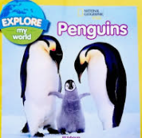  Compare and contrast  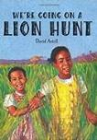 | Cycle 1  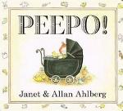  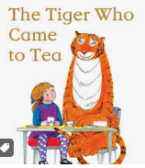 | Cycle 2  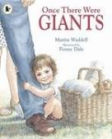  When I grow up  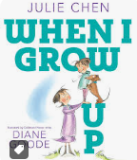 | Cycle 1  Jack and the beanstalk  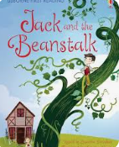  The BAd tempered Lady bird  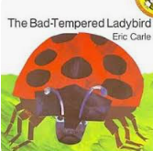 | Cycle 2  The Hungry caterpillar  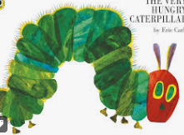  Monkey Puzzle  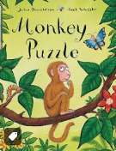  Rosie’s walk prepositions text Sum 2 |  | Cycle 1  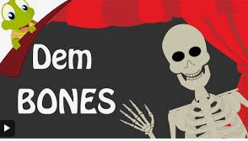  Storm Whale  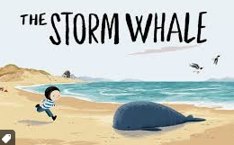  linked to beach theme | Cycle 2  Dem bones Poem  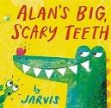  Beach Theme Text  Sharing a Shell  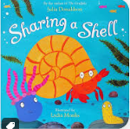
Key Vocabulary  (Including but not  limited to) | Cycle 1  Nocturnal, owlets, babies, alone, hunting, lonely, natural, unique, same, different, | Cycle 2  Happy, sad, angry, calm, scared, feelings, anxious, worried, missing home | Cycle 1  Notice  Countries globe  Similar  Different  Festival  Traditions  Hexham  Town  Journey  start, finish  next, then, after that  near, far  Country  Celebrate  Hexham | Cycle 2  Journey  start, finish  next, then, after that  near, far  Country  Celebrate  Hexham | Cycle 1  World  South Pole  North Pole  Desert  Wood  cold  freezing  freeze  cubs | Cycle 2  Globe  Habitat  Freeze  Drought  Notice  Similarities  Differences  Duke’s Wood  River | Cycle 1  In the past  History  artefact  Notice  Similarities  Differences  olden days  in the past  a long time ago | Cycle 2  Past  Now  Baby  Toddler  Child Adult  when I grow up- I want to be a…have parents in to tell the children about their jobs. | Cycle 1  Seed  Seedling  Life Cycle  Roots  Stems  Growth |  | Cycle 2  Habitat  Warmth  Cocoon  Metamorphosis  Life Cycle  Roots  Stems | Cycle 1  Balanced diet  Unique  Respect  Dem bones song and poem  Healthy choices  Unique  Special  rock pool  beach  sand  sea  sealife  whale | Cycle 2  teeth  brush  tooth  healthy  sugar  sweet  food  calcium  dairy  rock pool  beach  sand  sea  sealife  whale
Additional Texts  (Including but not  limited to) | Cycle 1  Owl Babies  (animals and their babies)  (TT) Goldilocks and the three bears  (NF) Owls and Owlets  5 little pumpkins- Halloween/ feelings song  Megs witch  One on the Broom | Cycle 2  Dogger  Harry and the Dinosaurs  Lucy and Tom at School.  My World Your World  You Choose  (NF) Making Faces | Cycle 1  Granny Went to Market  Handa’s Surprise  Peace at Last  (TT) Little Red Riding Hood  (NF) Welcome to our World | Cycle 2  We’re going on a bear hunt  We all went on Safari  Usborne - My Town  Poles Apart  (NF) Children’s Picture Atlas | Cycle 1  Three little Pigs  (NF) Polar Bears for Kids  The Bear  The Great Explorer  Lazy Lion  We’re Going on a Lion Hunt | Cycle 2  Three Billy Goats Gruff  If you were a Penguin  (NF) The Emperor's egg | Cycle 1  The Family Book  And Tango Makes Three  So much  (TT) The GingerBread Man  (NF) All About Families | Cycle 2  The Tiger that came to Tea  Mr Gumpy’s Motor car  Oi! Get Off our Train  (NF) Toys in the Past | Cycle 1  Jack and the BEanstalk  Oliver Fruit Salad  It’s OK to be different  Pom Pom is Super  (TT) The Little Red Hen  (NF) Fruits and Vegetables: Early learning picture book for babies, toddlers, kids, and preschoolers. |  | Cycle 2  What the lady bird heard  I lost my tooth in Africa  Supertato  Giraffes Can’t Dance  (TT) The Little Red Hen  (NF) Going to the Dentist (My First Time | Cycle 1  The Very Hungry Caterpillar  Tidy  Jaspers Beanstalk  (TT) Jack and the Beanstalk  (NF) My Little Bean Diary | Cycle 2  Superworm  Jim and the Beanstalk  Snail Trail: In Search of a Modern Masterpiece  (TT) Jack and the Beanstalk  (NF) Lifecycles: Caterpillar to Butterfly: 1
Science | Kapow - Changing seasons – Autumn lesson  I am a scientist (x5)  Explore the natural world through hands-on investigation.  NUSTEM  Cubetos- (Robotic engineer)  (loan Box)  Lighting Technician – torch shadows(Loan Box) |  | Kapow -  NUSTEM  Civil Engineer  Pharmacist |  | Kapow - Animal adventures. Exploring animals big and small, identifying similarities and differences. (x5)  NUSTEM Glaciologist |  | NUSTEM  Magnet  Engineer  Meteorologist |  | Kapow - Our beautiful planet  Discovers the natural world by planting seeds etc. (x5)  NUSTEM  Arborist |  |  | NUSTEM  Marine Engineer  NUTSEM  Fluid Scientist- Bubbles
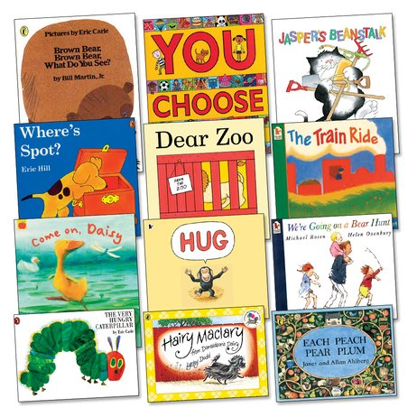  Including Pie Corbett’s Reading Spine Texts  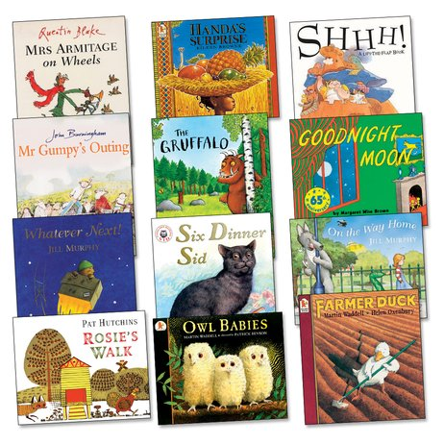 | 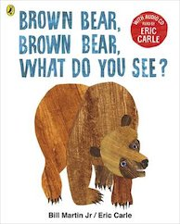 | 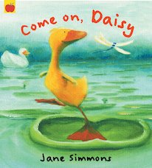 | 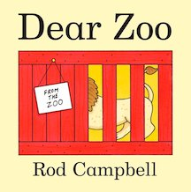 | 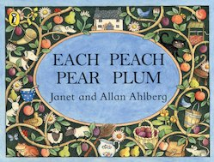 | 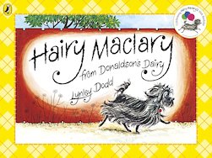 | 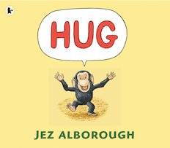 | 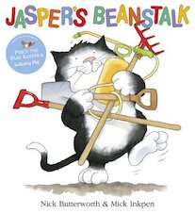 | 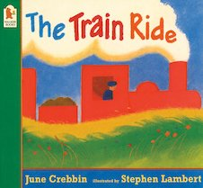 | 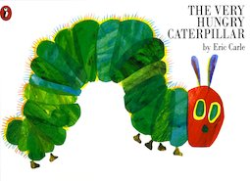 |  | 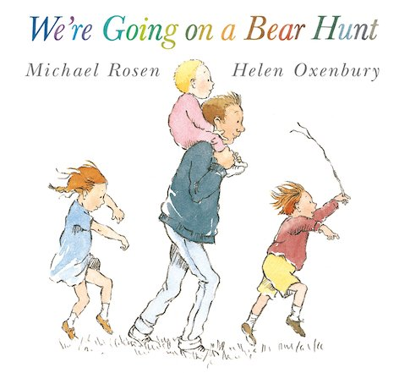 | 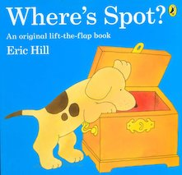
Traditional Tales | Autumn 1  Focus week  Settling in new school routines, zones of Regulation  Retelling, language enrichment, story sequencing. Links to the seven areas of learning. |  | Autumn 2  Focus week  Goldilocks and the Three Bears  Retelling, language enrichment, story sequencing. Links to the seven areas of learning. |  | Spring 1  Focus week  Three little pigs  Retelling, language enrichment, story sequencing. Links to the seven areas of learning. |  | Spring 2  Focus week  The Gingerbread Man  Retelling, language enrichment, story sequencing. Links to the seven areas of learning. |  | Summer 1  Focus week  The Little Red Hen  Retelling, language enrichment, story sequencing. Links to the seven areas of learning. |  |  | Summer 2  Focus week  Jack and the Beanstalk  Retelling, language enrichment, story sequencing. Links to the seven areas of learning.
Pie Corbett’s Poetry spine Poetry Nursery | 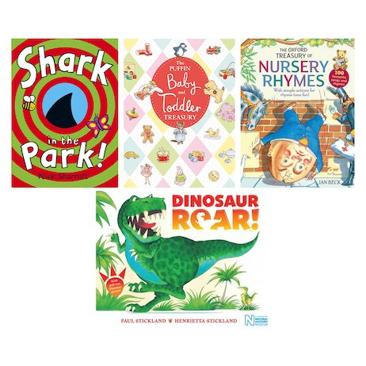 |  | 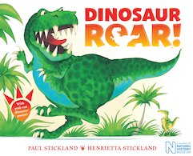 |  |  |  | 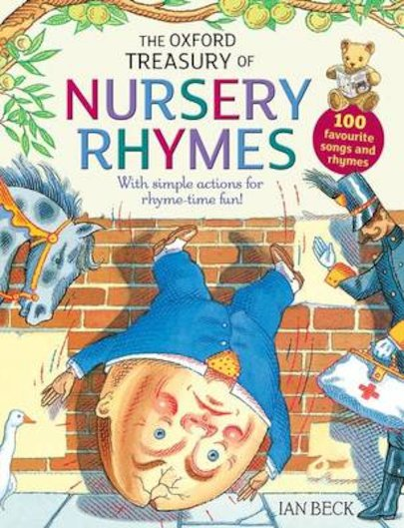 |  | 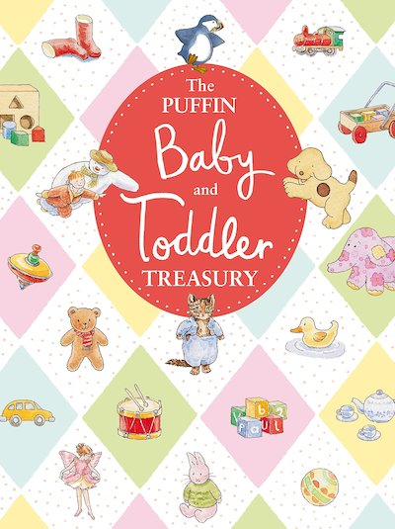
Pie Corbett’s Poetry Spine Reception | 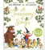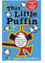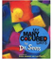 |  | 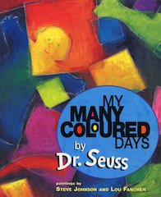 |  | 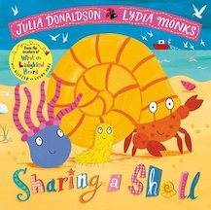 |  | 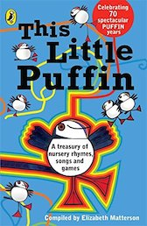 |  | 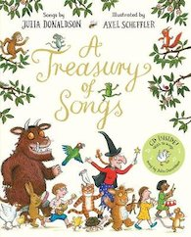 |  |  | 