Theme/Term | Autumn 1 |  |  |  | Autumn 2
Writing Root /  Spelling Seed Text |   Tar Beach - Faith Ringgold | 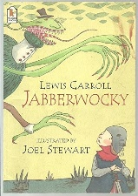  Jabberwocky - Lewis Carroll |  |  |   Shackleton’s Journey - William Grill | 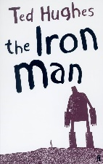  The Iron Man - Ted Hughes
Length | 15 sessions, 3 weeks | 10 sessions, 2 weeks |  |  | 15 sessions, 3 weeks | 18 sessions, 3+ weeks
Outcomes | Narrative retelling as a play script Poetry, setting descriptions, formal letters, dialogue (as a script) | Nonsense poems Performance poetry, explanatory descriptions |  |  | Newspaper reports Packing lists (justifications), letters (formal and informal), interviews, diaries | Mystery narratives Character descriptions, short news bulletins, letters of advice, diary entries, menus, logbook entries
Literary Leaf Text | 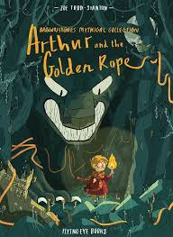  Arthur and the golden rope  Joe Todd-Stanton |   Zombierella  Joseph Coelho |  |  |   Poems from a Green and Blue Planet  Sabrina Mahfouz |   The Wild Robot  Peter Brown
Length | 12 sessions, 2+ weeks | 15 sessions, 3 weeks |  |  | 15 sessions, 3 weeks | 15 sessions, 3 weeks
Theme/Term | Spring 1 |  |  |  | Spring 2
Writing Root /  Spelling Seed Text |   Winter’s Child - Angela McAllister |  |   The Lion and the Unicorn - Shirley Hughes |  | 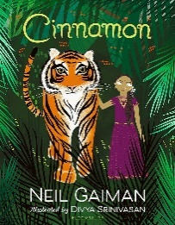  Cinnamon - Neil Gaiman | 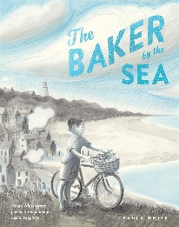  The Baker by the Sea - Paula White
Length | 15 sessions, 3 weeks |  | 18 sessions, 3+ weeks |  | 16 sessions, 3+ weeks | 15 sessions, 3 weeks
Outcomes | Fantasy story sequels Descriptive poems, postcards, dialogue, setting descriptions as letters, retellings |  | Own version historical narratives Letters, diaries, character and setting descriptions, non chronological reports |  | Own version fables Diaries, informal letters, dialogue, adverts, limericks and other poetic forms | Tourist brochures Job applications, advertisements, setting descriptions, letters in role
Literary Leaf Text | 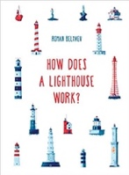  How Does a Lighthouse Work?  Roman Belyaev |  | 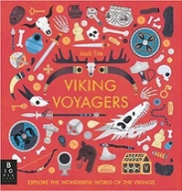  Viking Voyagers  Jack Tite |  | 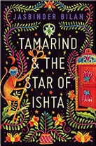  Tamarind and the Star of Ishta  Jasbinder Bilan |   The Poet’s Dog  Patricia MacLachlan
Length | 12 sessions, 2+ weeks |  | 15 sessions, 3 weeks |  | 15 sessions, 3 weeks | 15 sessions, 3 weeks
Theme/Term | Summer 1 |  |  |  | Summer 2
Writing Root /  Spelling Seed Text | 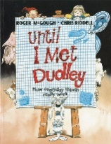  Until I Met Dudley - Roger McGough and Chris Riddell |  |  | 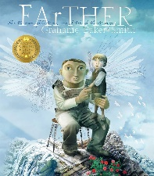  FArTHER - Grahame Baker Smith |   The Matchbox Diary - Paul Fleischman | 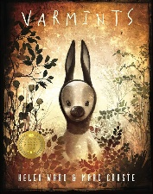  Varmints - Helen Ward
Length | 10 sessions, 2 weeks |  |  | 15 sessions, 3 weeks | 15 sessions, 3 weeks | 16 sessions, 3+ weeks
Outcomes | Two explanation texts - formal and informal Letters, short explanatory paragraphs |  |  | Sequel stories Retellings, recounts (postcards), setting descriptions, diary entries, instructions | Biography Dialogue, diary entry, retelling (oral dictation), mini autobiography, fact file | Explanations of a life cycle Diary entries, instructions, letters, descriptions, speeches
Literary Leaf Text | 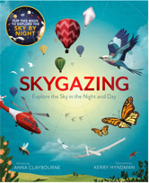  Skygazing  Anna Claybourne |  |  | 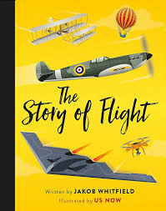  The Story of Flight  Jakob Whitfield | 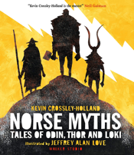  Norse Myths  Kevin Crossley-Holland | 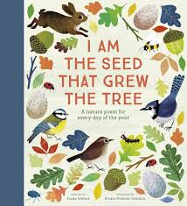  I am the seed that grew the tree  Fiona Waters
Length | 15 sessions, 3 weeks |  |  | 12 sessions, 2+ weeks | 15 sessions, 3 weeks | 12 sessions, 2+ weeks

