English  In English we are making the most of our Stone Age to Iron Age history topic. We will be reading the story Stone Age Boy and writing our own portal/adventure story. We will also be learning how to write a set of instructions based on the book ‘How to Wash a Woolly Mammoth’.  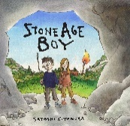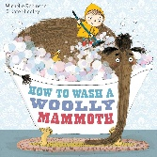 | 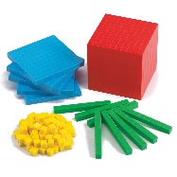  Maths  In Maths we continue to use practical resources such as Base Ten to add and subtract numbers mentally, including: a 3-digit number and ones; a 3-digit number and tens; a 3-digit number and hundreds. We will continue to practise our 2x,5x, 10 x tables and will begin to learn our 3x,4x and 8x tables. | Science  In our Science this term our topic is ‘Rocks, Soils and Fossils.’ We will be comparing different properties of rocks, learning where they come from and how they differ, learning the components of soil and soils differ, and learning the basic process by which a fossil is formed.  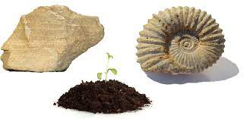
P.E & French  In P.E we will be learning a range of skills in gymnastics. We will also be walking down to take part in weekly swimming lessons.  This Photo by Unknown Author is licensed under CC BY-NC  In French we use the Language Angels programme. Through lots of verbal practice, we will learn how to say ‘I can…’ followed by 10 different activities we can do. | Year 3 Curriculum Plan  Enrichment  Lantern making for the Hexham parade.  Books we will read together  ‘The Sheep Pig’ (Vipers guided reading sessions).  ‘Stone Age Boy’ (English lesson text).  ‘How to Wash a Woolly Mammoth’ (English lesson text.)  ‘Charlie and the Chocolate Factory’ and ‘Kensuke’s Kingdom’ as story time books. | Computing & Design Technology  In Computing, we will be learning how to create stop-frame animation using IPads.  In Design and Technology, we will be designing, building and evaluating the 3D model we make of Egger, in relation to our recent Geography topic about the local factory.
Creative Arts  In Music we are continuing with having ukulele lessons with a specialist and on alternate weeks we will have lessons in learning the recorder.  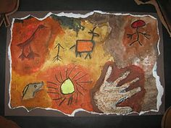  In Art, we will be exploring the gestural use of charcoal in the form of cave art, in relation to our History topic on the Stone Age. | Topic  In History we will be learning about how the lives of our ancestors changed from the Stone Age through to the Iron Age, and becoming equipped with the skills of interpreting evidence that give us clues about the past.  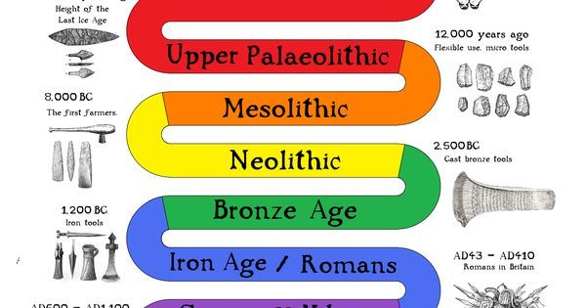 | RE & PSHE  In RE we are thinking about what Christians learn from the Creation Story and what is it like for someone to follow God as a Christian.  In PSHE we will be learning about Families and Relationships, followed by Health and Wellbeing.

