English  Texts: The Hodgeheg  Reading: Through English lessons, individual reading and guided reading we will:  - Listen to and discuss a wide range of fiction and predict what might happen from details stated and implied.  - Participate in discussions about books that are read.  - Apply growing knowledge of root words, prefixes and suffixes both to read aloud and to understand the meaning of new words they meet.  Writing: Through our text we will be learning skills such as:  - Discuss writing similar to that which they are planning to write  - Compose sentences, building a varies and rich vocabulary and an increasing range of sentence structures. | Maths  In Maths we will look at:  - Place value within  - Addition and subtraction  - Multiplication and Division  - Measurement: Area | Science  In Science we will look at sound. We will identify how sounds are made, associating some of them with something vibrating. Recognise that vibrations from sounds travel through a medium to the ear. We will find patterns between the pitch of the sound and features of the object that produced it. We will recognise that sounds get fainter as the distance between the sound source increases.
P.E  In PE we will be focusing on an invasion game of tag rugby. We will develop our basic skill of tag rugby and think about how to use core skills and apply basic tactics in order to attack the opposition. We will learn to make informed decisions during small sided games and plan attacking ideas.  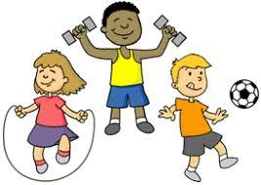 | Year 4 Curriculum Plan  Autumn Term 1 | Computing and Design & Technology  In comput  In Computing we will apply our knowledge and understanding of networks, to appreciate the internet as a network of networks which need to be kept secure.  In Design and Technology the children will plan, design and make a 3D sculpture of Egger using a variety of junk modelling equipment and different joins and media.
Enrichment
Representative visitor from Egger

Books we will read together
The Hodgeheg

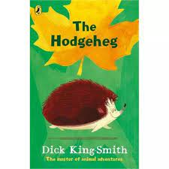
Creative Arts  In art we will be exploring how to create optical illusions. We will then look at M.C. Escher idea of tessellation and explore which shapes are better for tessellation patterns.  We will then explore different sketching techniques such as mark making, light and dark tones and shading to help us to eventually sketch Egger.  In music we will look at the song ‘Hands, feet and heart.’ We will start our ukulele lessons. | Geography  Egger  In Geography we will study a local area focusing on jobs and resources. Our study will focus on a local manufacturing company Egger. We will look at the different primary and secondary resources used in Egger and we will understand Egger’s impact as a local employer. We will look at how Egger try to decrease their impact on the environment.  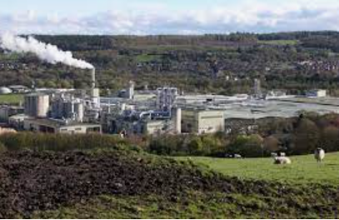 | RE and PSHE  In RE we will look Christianity and try to answer the question ‘What is the Trinity and why is it important to Christians?’ We will look at the importance of water used in a Baptism. We will then explore the idea of a gospel and look specifically at John the Baptism. We will then look a how different artists have captured the Trinity in their paintings of baptism and we will finally create our own art of a Baptism.  In PSHE we learn that families are varied and differences must be respected; understanding physical and emotional boundaries in friendships: exploring the roles of bully, victim and bystander.  