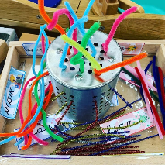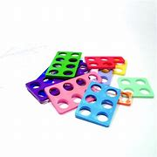

**Specific Area: Expressive Arts and Design (EAD)**

Through our key text we will:

Made a Gingerbread Man

Polar animal artwork

We will have access to the:

Craft area

Paint

Playdough

Small and large box modelling

Collage

Key text exploration

Work bench

**Specific Area: Understanding the World (UW)**

We will learn about and explore:

Chinese New Year

The winter season

Looking at colder climates

Changes in environment during winter



***Reception Medium Term Plan***

***Spring***

*The experiences outlined here will be included during Spring Term but is not limited to these experiences. We will look forward to seeing where the children’s interests and needs take us during spring.*

*Our Key texts are:*

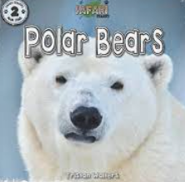 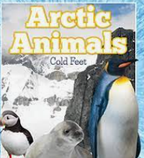

**Prime Area: Physical Development (PD)**

We are so lucky to take part in:

We have a funky finger table set up with different activities each week to promote fine motor skills.

We take part in two PE lesson once a week – this term our focus is multi skills which includes throwing and catching.

We have fabulous open ended outdoor resources chosen to challenge our fine and gross motor development.

Children access bikes and trikes on Tuesdays and Thursdays. Children can bring their own wheels for these sessions.

**Prime Area: Personal, Social and Emotional Development (PSED)**

Through our key text: Non-fiction and Traditional Tale The Gingerbread Man, we will learn:

Instruction writing

List writing

Labelling arctic animals

How to be safe in the cold weather, wearing scarfs, gloves and hats.

**Primer Area: Communication and Language (CL)**

We will take part in circle times listening appropriately and asking relevant questions

We will start to listen and take parts in story times.

We will learn new nursery rhymes

We will sing new songs

We will begin to learn and use Makaton

**Specific Area: Literacy (L)**

Following the phonics scheme Read, Write, Inc. Children in Reception will:

Read single-letter Set 1 sounds and read all Set 1 sounds; blend sounds into words orally, and Set 2 sounds.

We will:

Instruction writing

List writing

Labelling arctic animals

Looking at non-fiction texts including title and contents pages.

**Specific Area: Mathematics (M)**

Getting Alive in Five

We will be looking at numbers 5-10, composition, subtising, 1 more and 1 less, representing numbers and sequencing.

Capacity

Length, height and time

3-D shapes

Our traditional tales are Gingerbread Man and Jack and the Beanstalk.